[1]

REST Client Service

Assignment 4

Kwangkyu Choi

This project is basically load data from online url to mobile app using REST Client service. I used retrofit to interact with http which deals with json and gson etc.

# INTRODUCTION

This project is simply about loading json data from a website to an application using REST Client service. I used retrofit API to accomplish this project. Retrofit API deals with not only Gson but also other types such as Jackson, Moshi .. etc.

In this project, I needed to retrieve most of data from “**https://jsonplaceholder.typicode.com/**”as the mock back-end interface. This webpage is structured clean and nice for developers to easily understand path and how it works.

# Application Design

I implemented a permission to use internet in manifest. I have three activities for each page described in instructions. One for posts, one for a selected post and comments to it, and the other for a user profile and posts associated with the user. In the post activity, I retrieved 100 posts from given url + “/posts”. In the selected post and comments activity, I retrieved selected post and comments associated with it which ends like “/comments?postId=1”. In the user profile activity, I retrieved data related to the username that I clicked on in second activity. Also, I retrieved posts that is created by the selected user. I use three different adapters for each activity. I have a FloatingActionButton for POST request to http in second activity(which is for a post and comments) and this is not dynamic. I am missing one function that is presenting the location of the user in user profile activity.

For UI and UX, I did not have enough time to organized in good looking. So, UI and UX is bad. This app is just doing what it is supposed to do.

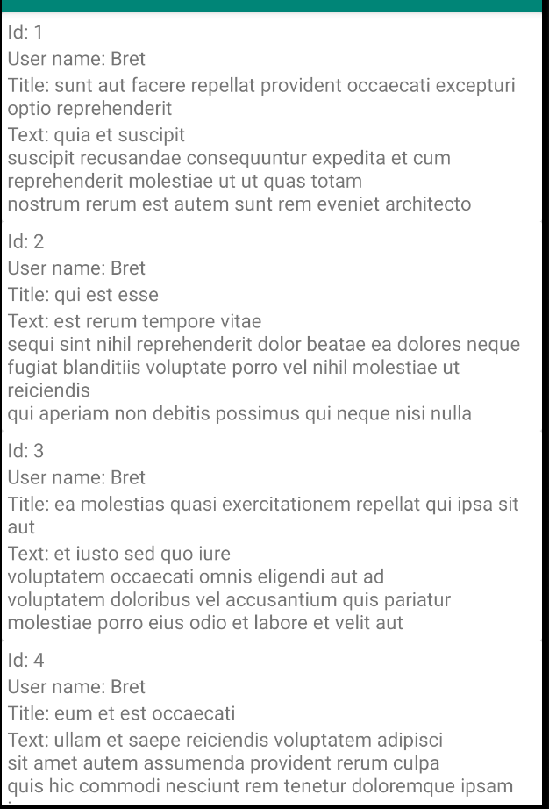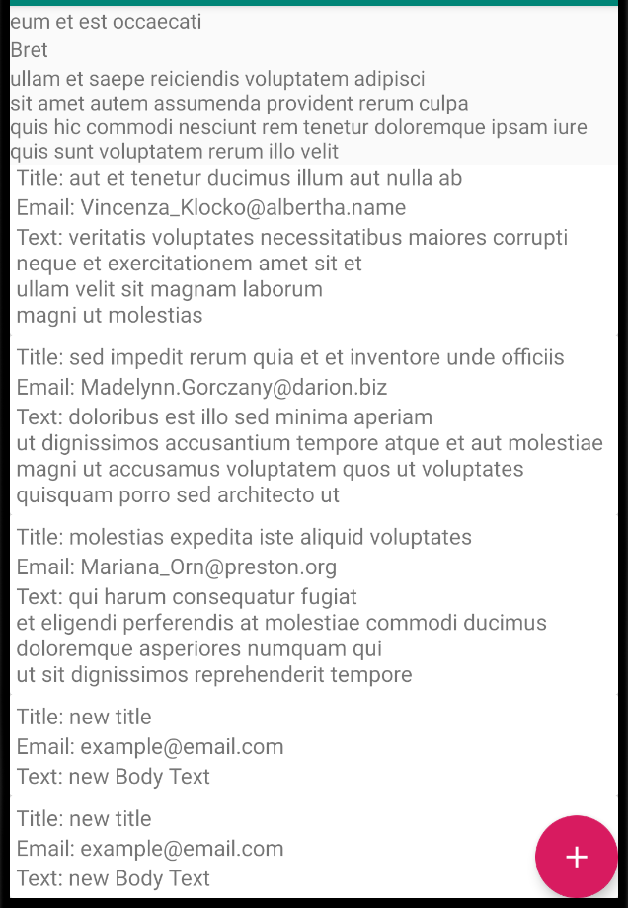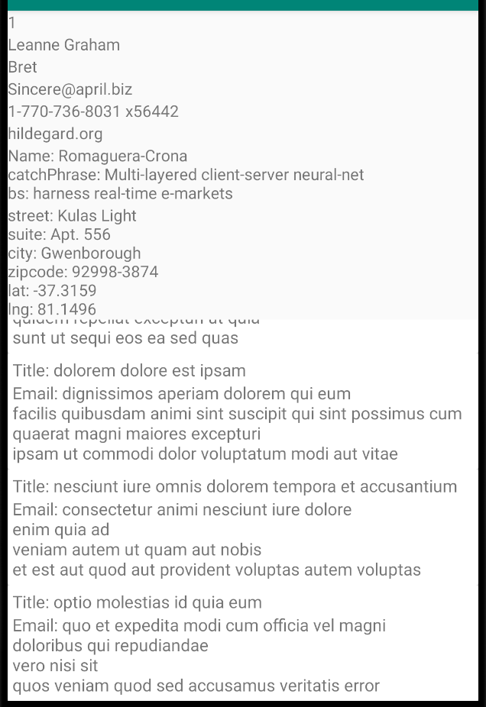

# Results

My application works with most of the functions which are supposed to work besides having a location of a user in the user profile activity. I have experience of crash sometimes when I have weak wifi connections. However, it will have accurate data and works just fine other than unstable case.

1.